UPdATE ON THE DARGUES REEF PROJECT AUGUST 2015

Angela Lorrigan
Unity Mining Ltd Level 10, 350 Collins St Melbourne 3000
Keywords. Gold, Dargues Reef, Granodiorite, Braidwood, Major's Creek.

Abstract
The Dargue's Reef Project is centred on the Dargue's Reef Resource, a gold Resource which totals, in Inferred, Indicated and Measured categories:
1,615,000t @ 6.3g/t Au for 327,300oz Au (<2g/t cut-off).
The Dargues Reef Definitive Feasibility Study pre-empts a +50,000oz pa gold operation. It is planned that the operation will mine 330,000t p.a, using conventional long hole open stope mining methods via a decline. At the time of writing a modification of the project plan to, among other things, enable cyanide treatment of the ore on site was on public exhibition.
The mineralisation at Dargues occurs within the Devonian Braidwood Granodiorite. This rock type intrudes the underlying Ordovician Sediment package of the Adaminaby Group, which is in part overlain, in the west, by the Siluro-Devonian Long Flat Volcanics.
The ore body occurs within east-west striking lodes which, though they have the overall geometry of vein structures, are comprised entirely of disseminated, gold-bearing pyrite, within an alteration envelope that extends up to 80 m from the main lode material. Alteration minerals include carbonate, white mica, chlorite, epidote, illite, montmorillonite, kaolinite and magnetite destruction. Pyrite comprises 5-30% of the lode material and occurs as disseminated crystals of up to 1 cm. size and as aggregations which average around 1 cm. in size. The free gold is mostly within the pyrite grains.
Quartz vein-hosted gold also occurs within the area but does not form any part of the Dargues Resource. The geological setting of the deposit is shown in figure 1 (below).

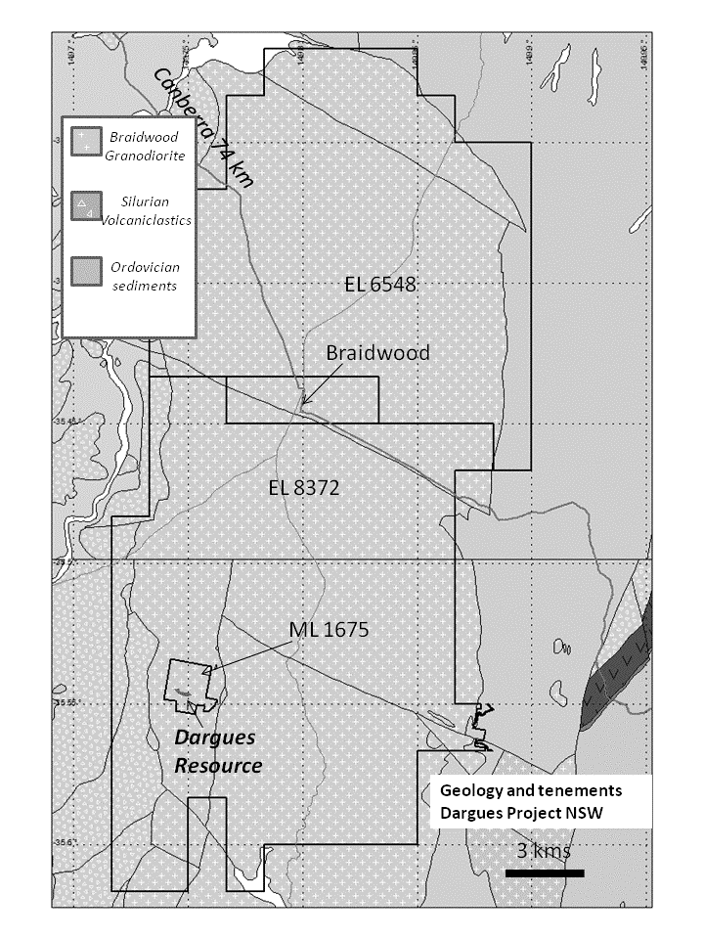

Figure 1. Geological map showing the location of the Dargues deposit.

In 2014 a review of exploration the in the vicinity of the Dargues deposit was undertaken with a view to determining a clear exploration strategy for future work.
This review looked at 3 elements of previous exploration.
1. The use of soil sampling.
2. Mapping alteration minerals
3. The use of geophysics, particularly I.P.
The following conclusions were reached with respect to each element:

1. Soil sampling
An extensive review of soil sampling had already been carried out as part of a research project initiated by Cortona (Halley 2009). The key finding of this was that soil samples need to be assayed by consistent methods with low detection limits. This approach would minimise batch effects and enhance the "visibility" of wide alteration zones in the soil sample data.
A comparison of pre-2011 soil sampling, in which sieved, A horizon soils were assayed, with post 2011 sampling in which the soils were sourced from unsieved B horizon, showed that the latter were far better at locating anomalous bedrock. This is partly because of a transported component in the A horizon soils but also because the earlier samples were assayed by a technique with a higher detection limit.

2. Mapping alteration minerals
It was noted that for the most part, the Braidwood Granodiorite is not heavily vegetated and that remote sensing may detect alteration signatures on a wide scale and therefore highlight areas for closer interest.

3. Geophysics
Review of both the E-W and N-S aeromagnetic datasets showed that the existing interpretations would benefit from re-processing. Similarly, it was determined that the re-processing of historic gradient array, pole-dipole and dipole-dipole surveys over the Dargues deposit itself was warranted. This particularly because the lack of an I.P. signature for the deposit was a curious thing, given the quantity of disseminated sulphide.
Subsequent to these determinations, the following work was done:
1. New soil sampling over previously untested areas using B Horizon soils was undertaken and these results were combined with older datasets, employing a Z-score levelling technique. This produced a more consistent dataset, though clearly, it still had its deficiencies because of the incorporation of older data.
2. ASTER satellite imagery data was purchased and analysed using ENVI software (Vukovic, 2014). This work showed a zonation from mineral assemblages consistent with cooler, higher pH fluids (illite, muscovite, smectite, +/- carbonate and haematite in the centre of the area to minerals (such as alunite and pyrophyllite) denoting hotter, more acidic fluids in the south (though it was noted that this mineralogy could have also been the result of acidic weathering due to sulphides). The Dargues ore body lies at the transition point between these zones. There is also a background, chloritic alteration, which is probably metamorphic and dominates the northern EL. Figure 2 below shows the distribution of this alteration.

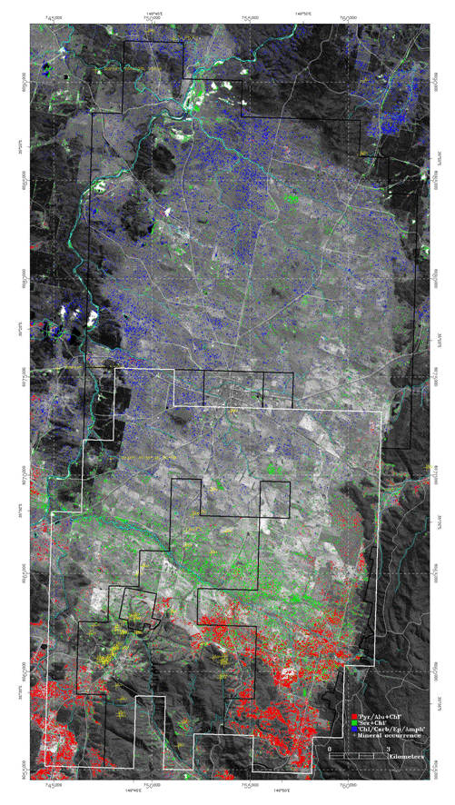

Figure 2 ASTER map showing distribution of mineral assembalges.

3. Re-processing of magnetic data showed a clear Dargues signature, with an E-W zone of magnetic destruction intersecting a NE-SW trending structure and a complementary NW-SE-trending structure at the end of the E-W zone to form an "arrowhead" feature.
Re-processing of the I.P showed a detectable I.P. anomaly for the Dargues mineralisation in the Gradient Array and Pole-Dipole data and a very strong anomaly in the Dipole-Dipole data. The difference in the tenor of the anomalies was explained by a Diorite dyke, which runs parallel to and along the southern side of the Dargues deposit acting as a current barrier in the Gradient Array and Pole-Dipole surveys. Despite the differences in the surveys, the clear conclusion from this work was that the deposit has a readily discernible I.P. signature.
This work in itself generated a number of targets but in addition, it enabled a clear strategy for exploration in the Dargues area to be cast. This is as follows:
- Prioritise exploration in the area of "sericitic", that is the illite/muscovite/smectite areas, particularly where they border upon or overlap with the pyophyllitic zones.
- Compile a comprehensive database of soil assays, preferably all assayed by the same low-detection method and taken from the same point in the soil horizon.
- Define structures that exhibit magnetite destruction.
- Undertake I.P. surveying over favourable magnetic structures, prioritising those areas that co-incide with soil anomalism.
- Drill test I.P anomalies.

References
Cozens, G. 2014, Majoor's Creek Gold Project. Annual Technical Report for the period 3rd October-2nd October 2014. Unpublished Unity Mining Ltd report to NSW government.
Halley, S.D. 2009, Summary of a review of geochemical exploration at Major's Creek. Cortona unpublished company file note
Vukovic, D., 2014 Braidwood/Majors Creek Project, and Booths Reward Project and ELAs 4884 & 4885 near Gundagai, NSW –Aster mineral mapping summary report. Unpublished memo from Exploration RS and GIS to Unity Mining Ltd 7th March 2014.

